ENSE 374

Milestone 5: Usability Evaluation Discussion and Product Delivery

Software Group B

Members: Avery, Nic, Renz, Jiahao, Jinkai, Mackenzie

**Table of Contents:**

Introduction 3

Revised Content Strategy 3

Usability Evaluation Results 5

Pre-Task 6

Task/Post-Task 6

Course Navigation 6

Form Navigation 7

Contact Navigation 7

Safety Policy Navigation 7

General Improvements and Comments 7

General Comparison 8

Revisions from Evaluations 8

Discussion of Next Steps 8

Appendix A: Questionnaire 12

Appendix B: Questionnaire Responses 14

**Images:**

Image 1: Initial Homepage 4

Image 2: Sidebar Code 4

Image 3: Button sorting prototype 5

Image 4: Program navigation Initial 9

Image 5: Program navigation revised 9

Image 6: Sidebar Navigation 10

**Introduction:**

The milestone consisted of analysis of the initial lo-fi prototypes and the abilities of Cascade Server. With the implementation of the site, revisions were made, and many navigation paths were tested to attempt to make the site intuitive for users. The usability evaluation provided a good review of the site and helped to discover potential weaknesses as well as strengths to improve upon. The process allowed changes that would benefit the user to be added with the continuation of the project.

**Revised Content Strategy:**

From our initial lofi-prototypes our cascade server design did not differ all that much although there were some significant changes. Our main navigation, shown in image 1, changed to combine Research and Faculty in our early design. Most notably, the sidebars were not used although they are still an option if needed. This was due to the use of additional HTML and CSS, image 2, to be added using the source code editor on Cascade Server. As well, under programs only courses and committees ended up being added instead of also linking to faculty and forms. This was changed from the proposal to make navigation and page setup easier for users and make each section serve one purpose for easier navigation. We also changed the homepage from having dynamic content to having general information. Additionally, search bars were added to Courses, Forms, Safety Policies and other pages with the potential for long lists. Using buttons to sort content seen in image 3, was not implemented because of the additional code which would make setup more difficult for non technical users.

Image 1: Initial homepage with top navigation bar

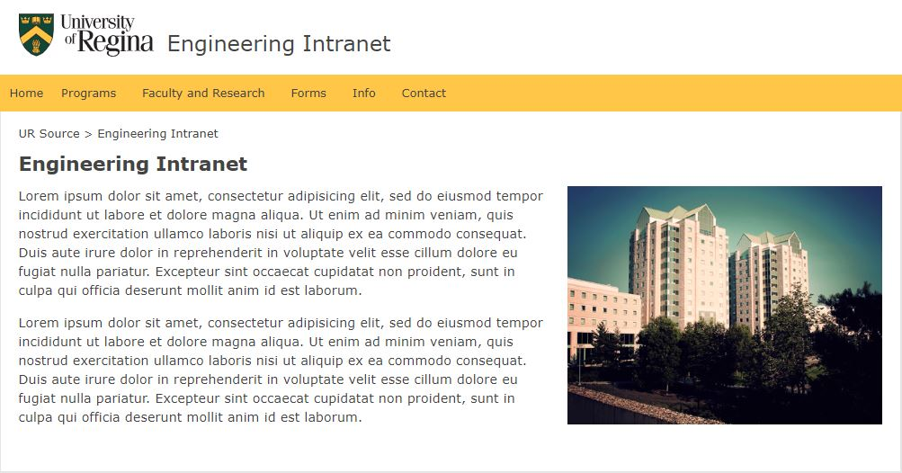

Image 2: Sidebar HTML and CSS

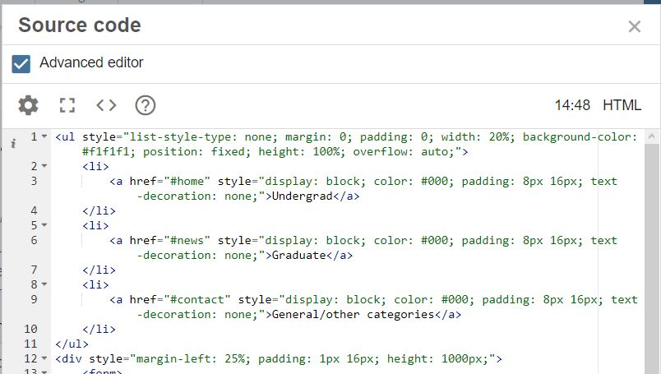

Image 3: Initial Button sorting prototype, from faculty page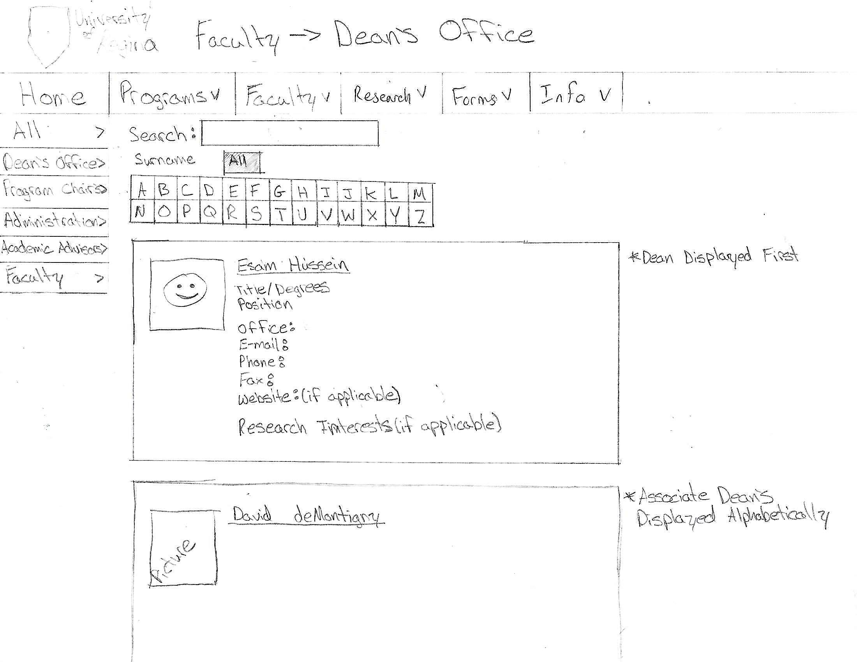

**Usability Evaluation Results:**

The questionnaire was designed to determine the usefulness to the user and where the site could be improved to benefit the user more. As a result there were pre-task, task, and post-task questions to determine the initial thoughts, the ease of navigation and overall result. Using the revised content strategy developed, the results were implemented onto Cascade Server for testing. Users were led through the questionnaire as they completed tasks, however if the user discovered something they wanted to discuss it was noted. The extra comments the users added were an important part of evaluating the site as a whole which may have been missed with the specific tasks. The questionnaire and results from user evaluation are shown in appendix A and B.

Pre-Task:

Our pre-task questions held the importance of getting an initial reaction and thoughts of the website. A well planned and setup site is necessary to try to give users a better experience. By getting suggestions not influenced by functionality, our implementation was tested to ensure it was not missing anything major in setup.

The pre-task questions were: “What are your initial thoughts of the site?” and “What do you think of the headings and navigation?”.

1. What are your initial thoughts of the site?

We summarized couples key responses of two pre-task questions from the users. The general look at the homepage, went over well for the appearance of simple navigation.

1. What do you think of the headings and navigation?

The major item mentioned by both users was considering committee as a different page. This was a point that was considered and not unexpected. It allowed us to confirm what the user wanted and gave a better idea for navigation and how to separate content. There was also mention of potentially larger drop downs for easier viewing.

Task / Post Task:

In general, the task/post-task questionnaire was similar with each set. These were set up in the format: Task, evaluate task, compare task to current implementation. This format allowed for a review of how the user navigated as well as getting insight into how the user perceived the task and what it improved or worsened when compared to a current equivalent task. The various tasks were, Find the page for ENSE 374, navigate to the forms page, navigate to safety policies, navigate to contacts. The post task questions were: “What are your suggestions to improve this?”, and “How does this compare to what is currently done?”.

Course Navigation:

Navigation to the specific course went well overall. It was suggested to reduce the clicks needed for navigation which happened later on from reorganization. The importance of few clicks to ensure engagement and ease of searching for users was noted. When compared to the current process, a book is used for course descriptions and pre-requisite which could be changed by adding a course description for courses on the course page. The searching functionality was seen as beneficial compared to scrolling through files, which make proper implementation important in the future.

Form Navigation:

The form navigation task provided more information regarding navigation and likes and dislikes of the system. Forms was shown as being sorted by programs which was seen as unnecessary. Forms are currently set up by security with logical groupings which could be mirrored on the prototype. The searching of forms was seen as beneficial to the process. A side navigation bar was noted by one user as potentially beneficial for navigation through form groups. The form navigation questions were among the most helpful and insightful due to the importance of the task.

Contact Navigation:

Contact navigation was a quick task due to the direct link on the main navigation bar. The main suggestion from one of the users was the addition of Dean’s Office contact information for users with general questions. The current system gives the office calls regarding where to find information which hopefully the site overhaul will assist with.

Safety Policy Navigation:

Safety Policy was noted as an important heading and users suggested a search bar being used, or similar to the form page suggestion a side navigation bar was suggested dues to various categories. The importance of the page was an notable aspect that hadn’t been considered initially. The current navigation through a drop down under Info went over with no complaints, however could warrant the moving to the main navigation bar if it is not crowded.

General Improvement Comments:

The biggest suggestion is to have a dedicated committees page added within the intranet instead of having it as a dropdown of the program navigation head. With this suggestion, it will not only produce logical organization of the intranet for the fact that committees go across programs but it will also allow users to now have fewer clicks when navigating any context under the heading of programs.

Another suggestion is to have faculty and research divided into their own individual pages. Similar to the first suggestion, this will allow for less confusion when navigating the intranet as well as allow users the fewest clicks to get to what they need to get to. To dive deeper, the faculty page having an abundant amount of information — containing all the staff members and their associated research interests, contact, photos, etc — is an okay structure but having research as an individual page containing on-going research, laboratories, and such will make the organization of the intranet overall better.

The addition of a search bar within specific pages would produce less confusion as well as allow for tasks to be done as quick as possible with a few clicks.

General Comparison:

From what we have gathered, our delivered design compared to what is currently done will be more efficient due to the structure of its navigation bar and the inclusion of side navigation bars as well as search bars. Specifically, in terms of form navigation, having the forms structured in a more logical manner — event forms with events or new hire forms with application — compared to having it setup or sorted by their associated security will allow for a much more easier navigation

**Revisions from Evaluations:**

The notes taken from evaluations answered many questions and addressed aspects of the site that were not initially considered. The search bar functionality was commented on and appreciated on the pages it was added too. The search bar was also added to Safety Policies due to the potential for enough files that searchability would be an asset. A more major change was the moving of committees from the program tab to its own heading. This was a quick change and helped navigation of the entire site, committees was moved to a separate heading making it easier to find, this allowed each program to go directly to the courses of the program. The reduction of clicks to find content was discussed in the usability evaluations and achieved in part through this change, before and after shown in images 4 and 5. Other minor content changes were the addition of Dean’s Office to the Contact page, as well as a course description section to individual courses. A sample sidebar was added for additional review of difficulty of set up and functionality as requested during the evaluation. The result in Registration under Forms is shown in image 6.

Image 4: Program and Committee navigation initial

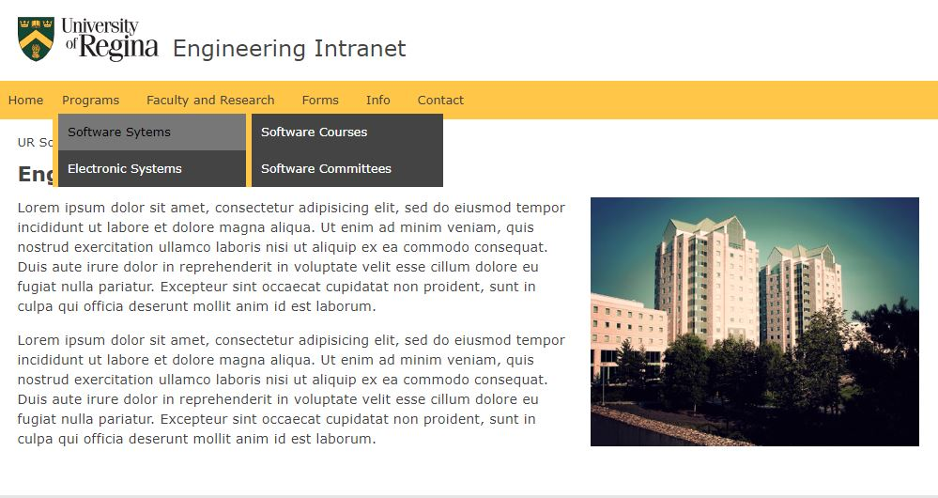

Image 5: Program and committee navigation reworked

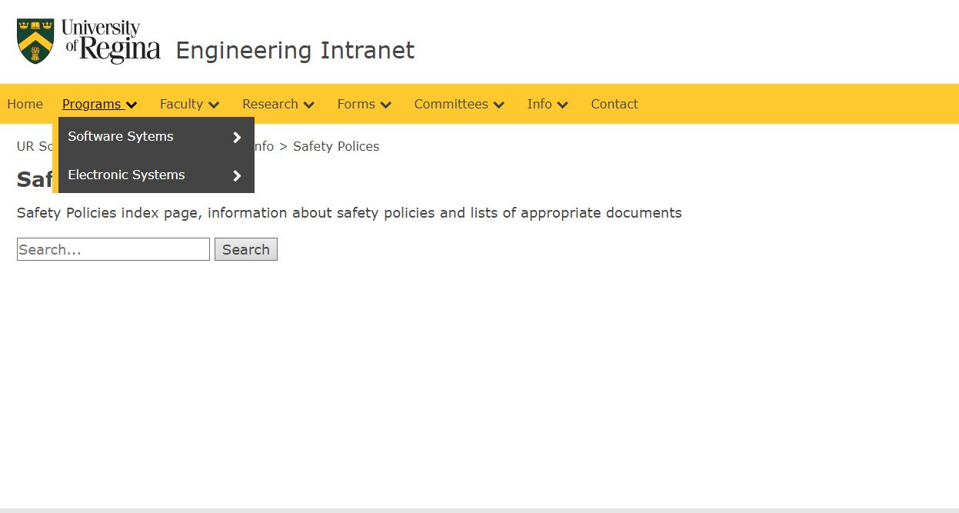

Image 6: Sidebar navigation in Forms

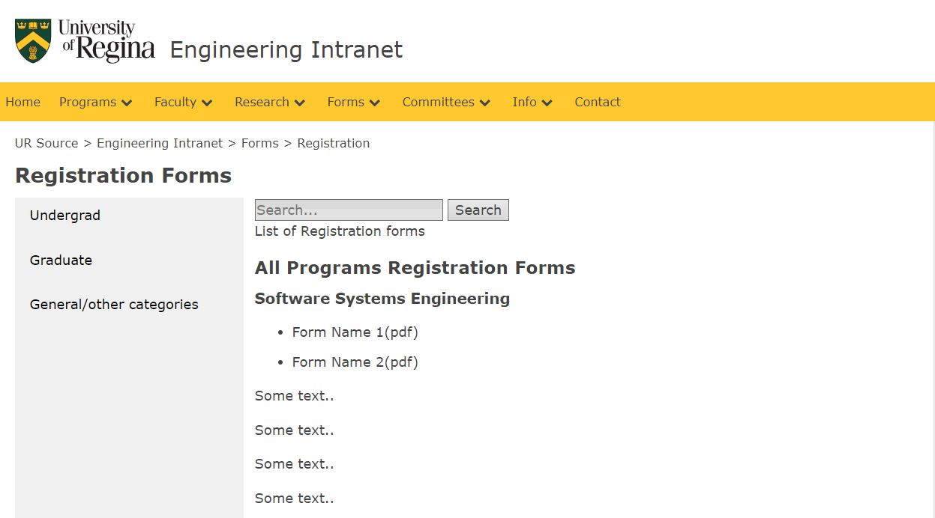

**Discussion of Next Steps:**

One of the biggest gaps in our proposal has is we only had administration staff use the site and fill out our questionnaire. This means we don’t have the feedback from all the different groups. Although we are confident in our design feedback, other areas could bring new insights. With the updated content, initial administration users may have additional feedback which could assist in ensuring a setup that is helpful for users.

The search bar for navigation which is on many of the pages with the potential for long lists of information needs to be implemented. This will need to be done working with a backend server to store and retrieve data when needed. A potential implementation could be the use of Asynchronous JavaScript And XML (AJAX). Through the use of AJAX, the search bar results could come up automatically without the reloading of the page which could help user navigation. An alternative would be simple PHP or whatever is available for use that will provide the necessary functionality.

The security of the intranet needs to be set up, either through user groups or individual users. Security permissions and what each role means and has access to should be documented to ensure that users do not have access to files they should not have. This would require an analysis of users so user groups and individuals are set up properly initially to reduce conflicts and problems in the future.

The search bar and security would be the main hurdles of a full implementation of the website, however depending of the process and programs available setup could be quick. Research into available resources would all for functionality to be realistic and thought out and reduce and unforeseen hurdles coming up.

Overall the site prototype is in a good initial state and lends itself well to future improvements and implementation. With additional resources and information security roles could be added as well with searching functions. The continuous process of the website creation has several iterations left, however the solid foundation will make implementation easier.

**Appendix A: Questionnaire:**

Engineering Intranet Questionnaire

Pre-Task:

What are your initial thoughts of the site?

What do you think of the headings and navigation?

Task and Post-Task:

Find the page for ENSE 374:

What are your suggestions to improve this?

How does this compare to what is currently done?

Navigate to the Applications Form Page:

What are your suggestions to improve this?

How does this compare to what is currently done?

Find Contact information for Administration:

What are your suggestions to improve this?

How does this compare to what is currently done?

Navigate to Safety Policies:

What are your suggestions to improve this?

How does this compare to what is currently done?

General Post Task:

What are your overall thoughts? Good, bad, interesting?

What do you think should be added or removed?

Any other comments or suggestions?

**Appendix B: Questionnaire Responses:**

